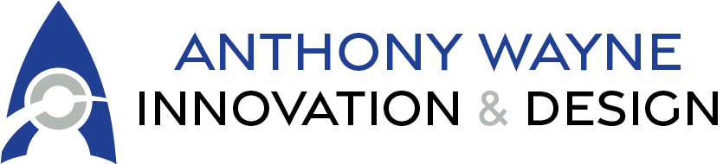

Course: Introduction to a Career in Tech
- Course Duration: 6-8 hours (Flexible for self-paced or one-day workshop)
- Target Audience: Individuals interested in exploring careers in technology.
- Prerequisites: None

Course Description
The Introduction to a Career in Tech course is designed for individuals interested in exploring opportunities in the technology industry. Whether you're considering a career change, just starting out, or looking for guidance on how to break into tech, this course provides an overview of tech careers, essential skills, and actionable steps to get started.
By the end of the course, participants will have a clear understanding of their potential career path, the necessary skills to develop, and the steps to take to successfully enter the tech industry. This course is ideal for beginners and requires no prior experience.

Course Objectives
- Understand the landscape of tech careers and industry demand.
- Identify key skills and certifications needed for various roles.
- Learn about different career paths, including software development, IT, cybersecurity, and more.
- Explore learning resources and job search strategies for entering the tech industry.
- Develop a personalized action plan for launching a tech career.

Course Outline

Module 1: Understanding the Tech Industry
- Overview of the technology industry
- Growth and demand for tech jobs
- Common misconceptions about working in tech
- Remote vs. in-office roles

Module 2: Tech Career Paths and Roles
- Software Development (Frontend, Backend, Full Stack)
- IT Support & Systems Administration
- Cybersecurity
- Data Science & Analytics
- Cloud Computing & DevOps
- UX/UI Design
- Product & Project Management
- Entry-level vs. specialized roles

Module 3: Essential Skills and Certifications
- Technical skills (coding, networking, cloud computing, etc.)
- Soft skills (problem-solving, teamwork, communication)
- Certifications and bootcamps (CompTIA, AWS, Google IT Support, etc.)
- Degree vs. self-taught vs. bootcamps: Which path is right for you?

Module 4: Getting Started - Learning & Building Experience
- Free and paid learning platforms (Coursera, Udemy, Codecademy, etc.)
- Building a portfolio (GitHub, personal projects, blogging) - Internships, apprenticeships, and freelancing opportunities - Open-source contributions

Module 5: Job Search Strategies & Breaking into Tech
- Leveraging LinkedIn and networking
- Preparing for tech interviews (behavioral & technical) - Navigating job boards and applications
- Alternative pathways (freelancing, starting a business, tech sales)

Module 6: Creating a Career Action Plan
- Finding mentors and communities (meetups, online groups) - Next steps: Roadmaps for different tech careers

Final Project (Optional)
- Create a personalized roadmap for entering the tech industry.
- Identify 3-5 learning resources and set short-term learning goals.
- Draft a resume tailored to an entry-level tech role.

